E20646 Stealth Traction card set up
This is what that board should look like. I set them all at full, no complaints yet
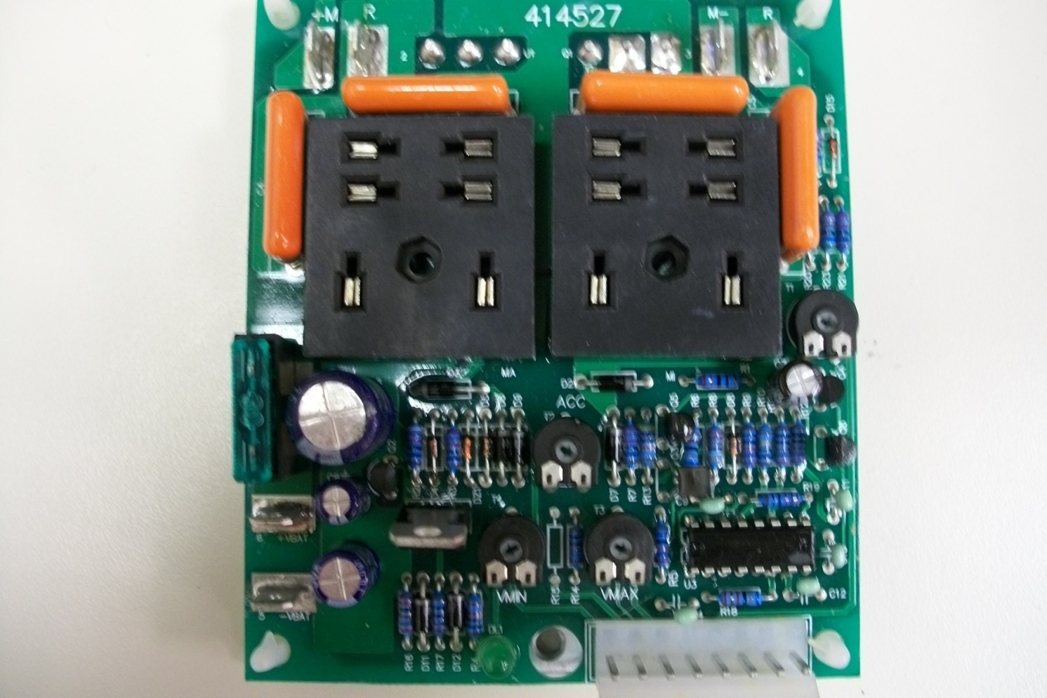
This one all the way counterclockwise These three all the way clockwise

This sets the Minimum voltage at its lowest setting, the maximum voltage at its highest, the acceleration on full (take off quick) and full IMAX (means full amps) which translates to full speed.

